The May 2006 trip to the Big Bend National Park started and ended with a ‘bang’.

Bobby Switzer, leaving home that morning at 5:30 AM decided to check-out the surface conditions of Highway 45 at the 59 cutoff. So he rode his bike into the asphalt with amour and head gear in place (unlike the first time he tried this experiment). He came out unscathed – with only minor rips and tears and a three inch raspberry on his knee – and oh yeah, some scratches on his beautiful red and black Valkyrie. He single-handedly righted his mighty stead and mounted the same – riding off into the sunrise.
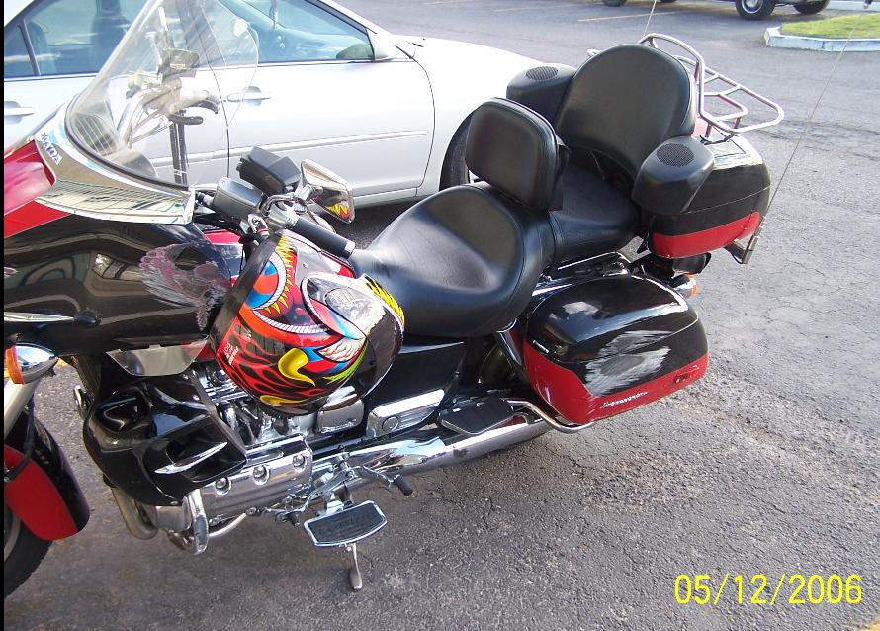
[By the way, since, Mr. Switzer is the editor of this newsletter – let it be known that if so much as one word is altered or the contents are amended – I will personally mail the unabridged version out to all members at my own expense.☺]
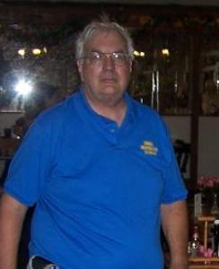
The group consisted of Bobby Switzer (obviously) and four more interesting people.

Rooney (Marvin Faudi -- from Waco). Rooney was the Tail-Gunner most of the time; that is except for his infrequent burst of energy at speeds approaching the speed-of-sound (I know that because as he passed us, there was no sound emanating from his Gold Wing – just a red blur). He was able to cross double-yellow lines with a single bound and perhaps even leap tall buildings (although he actually never did it, because there were no tall buildings to leap).
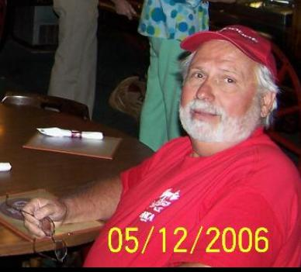

Rod (Rodney Sturman -- the Ride Captain) was driving a ‘cage’ with an ash tray, soft music, and an air conditioner. Rod peered-out at us frequently through his frosty windows to see if we were unraveling under the desert heat. Convinced that we were doing fine, he would crank-up the radio and air conditioner and press-on through the 106 degree temperature. He was thoughtful enough however, to broadcast the temperature periodically over his CB unit, for us all to hear. Every hour we could hear “79”, then later “83”, “89”, “92”, “97”, and finally “106” (that brought real joy to us all).
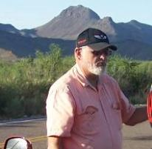

Cliff (Cliff Price – the Senior Member) was riding his new BMW CS-650 like a gazelle, with not so much as a look side-to-side; his aero-dynamic silhouette could be seen slithering quickly around even the most challenging of curves; at a constant speed of 70.0 miles per hour. Cliff was amazing – long duration rides with no water to offset the desert heat; he would not stop until we were finished and never complained.
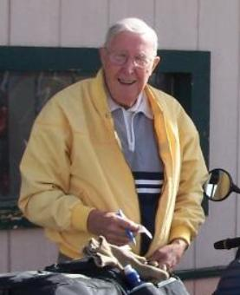

Flash (Dave Fashenpour – the New Guy), rented a Harley Electro-Glide Classic and had a ball -- that is, until I had my ‘big bang’. After passing an extraordinary observation parking area at the top of a very tall mountain – I announced to the group that I would be driving back to that location (by myself) in order to get a few photos… they acknowledged my quest and grunted goodbye (they were eating fried chicken and I am sure it was not a good time for conversation).
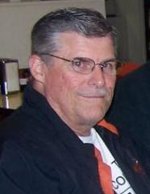

I say this because if they had been able to speak, they would have said – “oh no Dave, by all means do not park your Harley on the inclined parking lot because there have been 6,349 Harley’s that have parked there and have been laid-down as a result of the optical illusion created by the grade of the road against the parking area.” They did not say this – again, probably because of the chicken. But AFTER I parked on the incline and laid my Harley down – there were many interesting stories told (that I really would have liked to hear BEFORE I laid it down). You don’t suppose there were some chuckles heard as I drove off – of course that is not the case! (Shame on you).

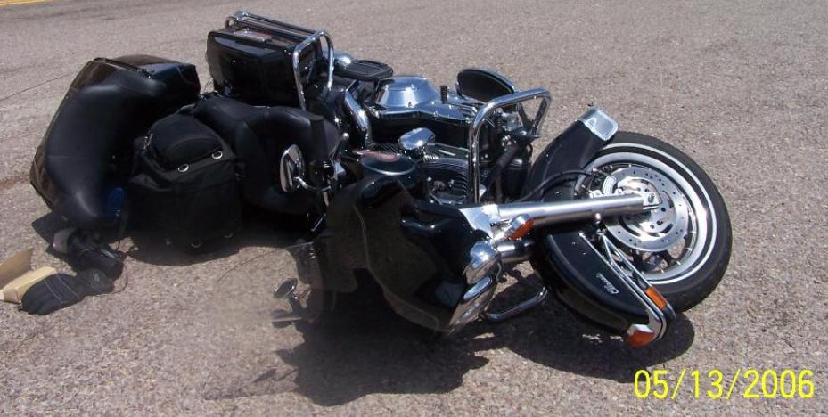

But let’s get back to the road trip. It was fantastic!! With the best company you can find, the most eye-popping scenery possible, and a full four days of just riding our bikes -- I won't forget this one for a very long time. Rod was the narrator and he did great, he told the stories behind the scenes. The plant that led to discovery of Neosporin, the Boy-Scout adventure in Santa Elena Canyon, the white-stuff (he had the correct name) that spewed out of the volcano and covered the entire area a mile deep, the big-horned sheep that snort at you to stay out of their territory, and about the people that commit suicide at the Basin’s Window. He made the mountains come alive and made for an extremely interesting experience.

We got the best cookies in the west at the refreshment stand in the McDonald Observatory and I loaded up with a wide variety of colored Gatorade and bottled water for our desert trip. Evidently these seasoned Retread riders – with six millions hours in the saddle – don’t need no stinkin’ liquids. Nor do they need to stretch every hundred miles, they must be iron-butt androids! Me, I am more refined – I wear chaps to keep me warm and toasty and to ease the pavement raspberries that seem to keep popping up on Switzer.

We visited the Terlingua Cemetery and placed coins on the sides of stone-pile grave plots, which must be the custom. We observed the care and love the people have for their deceased friends and relatives in a cemetery well over a hundred years old.

Feeling dehydrated, we went on a search for salt. We visited the Ghost Town saloon (in quest of salt – which was discovered sitting on the edge of a glass of frozen margaritas). We forced down the best margarita ever made.

We stayed in Study Butte, I think. It was hard to tell where the mythical Terlingua stopped and strange Study Butte began – but I do think they both exist. In the morning, outside our Easter Egg Motel we could hear the coyotes yelping at daybreak.

On the way home, three of us left Sanderson at 4 AM and on the way to Del Rio. The dark morning hours brought mule deer to the side of road, with smaller deer, rabbits, and a variety of small animals. Rod lead the convoy in his four-wheel Honda and was in constant CB contact to Rooney on his Gold Wing with a super lighting system. Flash was following along behind – braking and weaving through the dangers of animals wanting to cross the road. We made it alive – thanks to the fantastic efforts of Rod & Rooney.

We left May 12 (Friday morning) and returned May 15 (Monday afternoon). The following is the itinerary by day, of places we visited, motels we stayed in, and the roads that we took.

Day 1: Houston, San Antonio, to Fort Stockton on I-10.
Spent the night at the Motel 6 in Fort Stockton.

Day 2: Fort Stockton to Balmorhea on I-10 then to Fort Davis on 17.
(We also took the Ft Davis Loop road to the McDonald’s Observatory)
Fort Davis to Marfa on 17 and then to Presidio on 67.

That started the River Road from Presidio to Lajitas on 170 (106 degrees).
The final run was from Lajitas to Terlingua on 170.
Spent the night at the Easter Egg (aka.Chisos Mining Co. Motel) in Study Butte.

Day 3: Study Butte to the Big Bend National Park via Davis Loop on 118.
Spent most of the day in the Park, visiting Santa Elena Canyon, with lunch at the Basin.
Leaving the Park for Marathon on 385 and turned east to Sandersen on 90.
Spent the night at the Desert Inn Motel in Sandersen.

Day 4: Sanderson to Del Rio on 90, to Uvalde on 90,
to Hondo on 90, and to Castroville on 90, finally to San Antonio on 90.
We bypassed San Antonio on 1604, intersected with I-10 and headed home.

===============================================================

